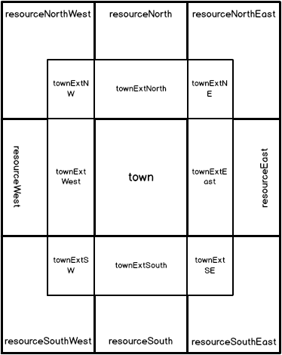
Town Division Mockup

Map Definition
Town Node
- The town node is the interaction point to see the users interactions
- Tapping the town node displays the Town Interaction Screen
Town Extension Node
- As the town grows in size, the town extension node visually represents the growth of the town
- There is no interaction with the town extension node. Tapping the node opens the Interaction Screens for the underlying Resource Node.
Resource Node
- The Resource node is the interaction point for the resources currently available in this node.
- Tapping the Resource node opens the Node Interaction Screen

Navigating the Map
- Each node takes up the full screen of the device
- Navigation occurs as the user swipes to the direction of the next node

Artwork Layers
- As the user progresses in the game, the region’s artwork evolves to get “busier”.
- The town extension nodes has more houses/buildings encroaching into the resource node
- The town extension nodes have several alpha building/town images that correspond to the towns growht
ie. townExtSW_initial.png
townExtSW_tier1.png
townExtSW_tier2.png //etc.
- The town ex nodes are displayed overtop the corresponding resource node.

